**Tutorial 23: Reaction Timer Game – Creating Game**

In this tutorial we will be focusing on getting the user to click on the square block as soon as it appears after clicking the play button. We want to determine how long it takes the user to click on the block as soon as the block appears.

Make sure **Tutorial 22** is complete to be able to move on to this tutorial or clone the [vue3-firebase-course](https://github.com/younggrasshopperza/vue3-firebase-course) repository and go to branch called **Tutorial-22**.

**Step 1:** In the **Block.vue** file, create a data property called timer and set the value to null. Create a data property called reactionTime and set the value to 0.

Look at the example below (**between line 13 to 14**):

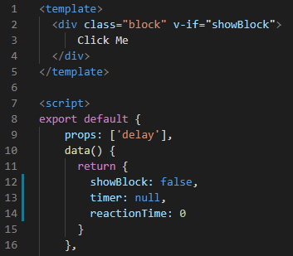

**Step 2:** In the **Block.vue** file, create a function called startTimer. The function will be responsible for incrementing the reactionTimer by 10 milliseconds until the user clicks on the block.

Set the timer to the setInterval function and increase the value by 10. Inside the setInterval function increment the reactionTimer by 10.

Call the function inside the mounted lifecycle inside the setTimeout function.

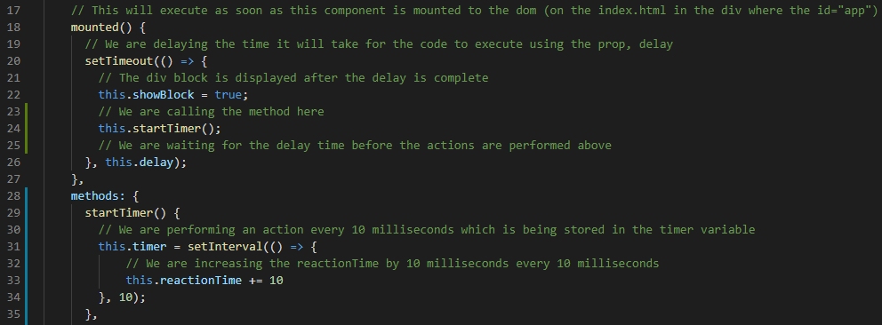Look at the example below (**between line 18 to 35**):

**Step 3:** In the **Block.vue** file, create a function called stopTimer. The function will be responsible for stopping the timer and clearing the timer data property.

Call the clearInterval function and pass the timer data property.

Look at the example below (**between line 39 to 40**):

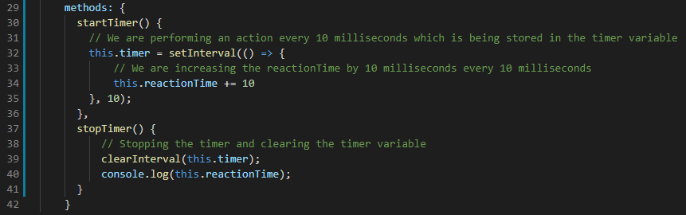

Create a click event on the div with the class block and call the stopTimer function.

Look at the example below (**between line 39 to 40**):

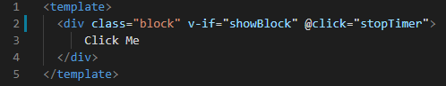

**Output:**

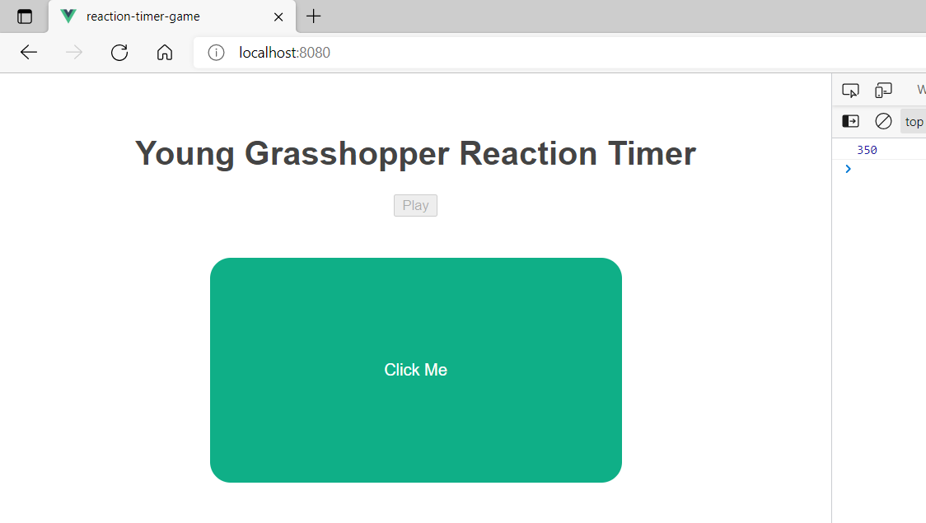

**You can view the code snippets from the** [**vue3-firebase-course**](https://github.com/younggrasshopperza/vue3-firebase-course) **repository under the Tutorial-23 branch**.